Sydney Oliver

Dr.Rocha

SRE Report

30 June 2022

**Methods:**

We conducted a survey in the Samuel Ecological Station in the southernmost part of the Brazilian Amazon, an area that has been greatly impacted by high rates of deforestation. This preserve lies along the shoreline of a reservoir created by a hydroelectric dam powered by the Jamari River. This area of land was set apart as a protected area by the Brazilian government as compensation for the great ecological damage the dam caused. This study was intended to provide a greater understanding of how terrestrial mammals' occupancy within the Amazon are being affected by environmental and anthropogenic factors. Data collection for this survey was done through camera trapping which is one of the most accurate forms of detecting species in an area as well as being the least invasive. From December 2018 to February 2019, 42 camera traps were placed within the Samuel protected region with an equal distance and distribution between each one; in order to capture the species of focus each camera trap was fastened securely 30 cm from the ground. The camera models used for this survey were the PC800 Reconyx Hyperfire and the HD Bushnell Aggressor. The cameras were not removed until the end of the survey date but each camera ,due to a plethora of factors, remained active for varying lengths ranging from 7-57 days. After the camera traps were removed from their particular sites and the data had been collected and processed it was revealed that 22 individual species of mammals were detected at least once. Each sighting represented only one detection as the functionality of the system does not account for the number of individuals in an area as we were testing the occurrence of species at a particular site.

**Data Analysis and Processing:**

The camera trap data collected from the individual sites was analyzed and processed through the statistical analysis software *R*. We used this software to clean and interpret the camera trap data to remove all non mammal species, correct typos with dates and locations and make sure that each time and location fell within the geographic time and range . We began by using *R* to group only the mammal species caught on camera as other species such as large birds were also captured in the camera history. This updated table was used thereforward instead of the generalized findings table from all 42 sites. This mammal table was combined with a number of covariates that were used to run models that would provide a picture of how species occupancy could be influenced. Camera trap sites were compiled in a similar way using packages provided by *R*.

*R* provides many means of functionality that extends past the basic application software and was primarily used for running occupancy models. Each model was run individually and combined with covariates that included human footprint index, edge & patch density, disjunct areas, net primary productivity, elevation, water surface level, forest coverage, distance to roads, and distance to rivers. As mentioned above each covariate was first run individually with the models before the best running models(tested better than the null) were combined to be run again providing a greater look at the outside factors affecting occupancy. Three species were of focus during the data analyzing and processing: puma, collared peccary and paca, however a fourth species was added to the running due to the lack of puma data and this species was the ocelot. The species mentioned were also of focus in similar surveys that were being conducted in different areas of the Amazon.

**Results:**

Using the package *unmarked* in *R*, occupancy models were run for the four species of focus within the Samuel Ecological Station. We used the function *modSel* to rank the univariate models in order of lowest to highest AIC in *R* to see which covariates, if any, would test better than the null model(mod0) and if some showed promise only the best ranking models were then run in combination with one another. For the three species, puma, paca, and ocelot there were no covariates that tested significantly better than the null. For this survey the data collected for both puma and paca proved to not be usable within this region due to the amount of times each one was detected; puma did not provide sufficient information and paca provided an overabundance of information which became too much for the software to handle. Due to the paca being so widespread and seen throughout most of the sites *R* cannot correctly estimate in order to model a graphical representation due to high levels of uncertainty.

Ocelot had a single covariate test better than the null, ~1~Fore, but this did not test at least 2 points lower and actually shared a similar AIC to the null. However when it came to the collared peccary the model that tested best was ~1~ ct_hfp(human footprint index). Out of the fifteen models that tested better than mod0, both univariate and multivariate, nine of them involved human footprint index showing that there is some level of correlation between human impact and the collared peccary(for model table see Figure 2). This model for the collared peccary represented that as human footprint increased within the Samuel Ecological preserve the probability of occupancy decreased(see Figure 1). The graphic displays a negative trend that shows an almost linear relationship between HFP and said species. This trend makes sense seeing as although peccary are rather abundant and have an extensive range they are hunted for food and their hides are used in local and sometimes international trade. The Samuel Ecological preserve is also one of the most impacted by human activity; deforestation around the perimeter as well as the illegal logging trade that occurs throughout parts of the preserve lend their hand in creating fragmented areas. There needs to be more research done in this area that has a heavy focus on the human-animal relationship to help devise a way to combat the effects of anthropogenic factors.

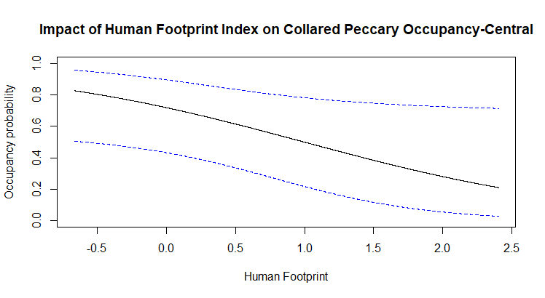

*Figure 1*

|  | nPar | AIC | delta |
| --- | --- | --- | --- |
| mod.psiRP.pEff2 | 5 | 213.00 | 0.000 |
| mod.psiHE.p2 | 4 | 213.09 | 0.090 |
| mod.psiHfp.p2 | 3 | 213.10 | 0.098 |
| mod.psiRP.p2 | 4 | 213.24 | 0.231 |
| mod.psiHnP.pEff2 | 4 | 213.57 | 0.568 |
| mod.psiHfp.pEff2 | 4 | 213.57 | 0.568 |
| mod.psiHnR.pEff2 | 5 | 213.70 | 0.692 |
| mod.psiHE.pEff2 | 5 | 213.72 | 0.717 |
| mod.psiRiver.p2 | 3 | 213.88 | 0.881 |
| mod.psiRiver.pEff2 | 4 | 214.44 | 1.439 |
| mod.psiHnER.pEff2 | 6 | 214.63 | 1.630 |
| mod.psiPatch.p2 | 3 | 214.75 | 1.743 |
| mod.psiPatch.pEff2 | 4 | 214.80 | 1.800 |
| mod.psiHnRP.pEff2 | 6 | 214.92 | 1.920 |
| mod.psiEWH.pEff2 | 6 | 215.15 | 2.147 |
| mod0 | 2 | 215.49 | 2.488 |

*Figure 2*